Friday 2nd April - 9am “live” Journeying with Jesus 2 – Peter’s denial

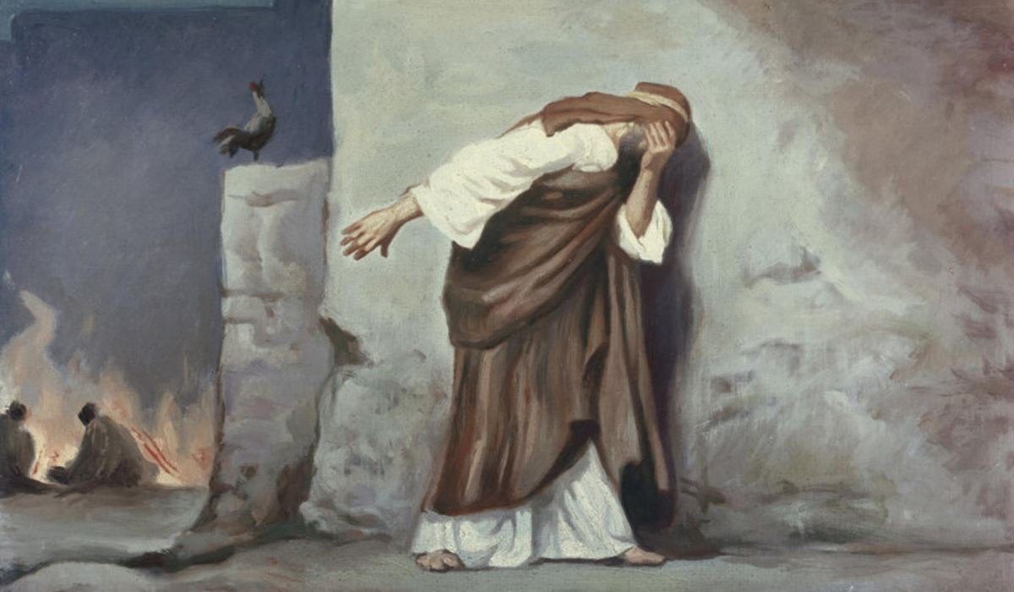
Why Did Peter Deny Jesus Christ? (christianity.com)

Mark 14

Peter Denies Jesus
⁶⁶ While Peter was below in the courtyard, one of the servant-girls of the high priest came by. ⁶⁷ When she saw Peter warming himself, she stared at him and said, “You also were with Jesus, the man from Nazareth.” ⁶⁸ But he denied it, saying, “I do not know or understand what you are talking about.” And he went out into the forecourt.^{[k]} Then the cock crowed.^{[l]} ⁶⁹ And the servant-girl, on seeing him, began again to say to the bystanders, “This man is one of them.” ⁷⁰ But again he denied it. Then after a little while the bystanders again said to Peter, “Certainly you are one of them; for you are a Galilean.” ⁷¹ But he began to curse, and he swore an oath, “I do not know this man you are talking about.” ⁷² At that moment the cock crowed for the second time. Then Peter remembered that Jesus had said to him, “Before the cock crows twice, you will deny me three times.” And he broke down and wept.
Not written off
Peter denied Jesus and it is an uncomfortable moment. Peter wouldn’t have believed it, no-one would with his devotions and commitment to Jesus. And yet Jesus was right. We know with hindsight that Jesus restored Peter even though he had denied him, it wasn’t the end. Jesus’ love remained.
Today’s musical offering is from Rock; the story of Simon Peter by Roger Jones. This song begins as the cock crows for the final time and Peter is left despairing. May it bring you a moment of reflection and time to consider God’s “look of love” at you.
Musical Reflection – The look of love https://youtu.be/XPG1iJrtwwI

Prayer
Lord, we come as we are. Warts and all! The good, the bad and everything in the middle. As Help us to look on others with your love not with the judgements of society, bias of our upbringing and inherited prejudices. As we look to others with such love may we grow in our appreciation and awareness of your love for us. Amen

