Carbon Weightwatchers in Feb 2022

CWW met via Zoom on Thursday 3 Feb when we talked about reducing carbon emissions from transport. I gave a talk to provide some basic information about different modes of transport and spread within this we had a series of short discussions about what we could do as individuals, as a church and what we needed local and central government to do.
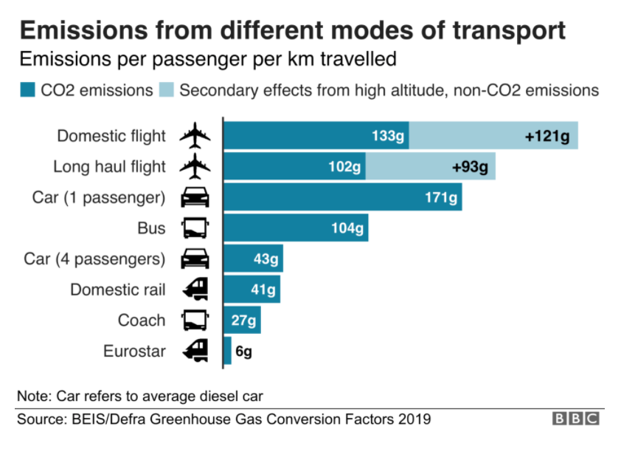
I started by explaining that greenhouse emissions from transport account for just over a quarter of the typical carbon footprint of someone in the UK. About 14% of a typical person’s footprint is from cars and 9% from flights. As a country we’ve not managed to make any reductions in emissions from transport over the last 25 years, in fact they have been going up. This means that we need to make some big changes to how we get around and we need to make them soon if we are to have any chance of meeting our targets for reductions.
We talked about flights first. This can be a difficult topic as I know that I, and many other people of my generation, will have taken many flights in our lifetime and the greenhouse gas effects from those flights are still in the atmosphere today, no matter what we do. I don’t therefore feel in a position to lecture people on not flying.
However, at the same time it is pretty clear that flying produces the largest greenhouse gas effect of any mode of transport (per passenger per kilometre) and reducing the number of flights we make as a society is essential to get us to net zero.
A useful statistic here is that 80% of flights are taken by 20% of the people. When this was discussed at the UK Climate Assembly (a group of 100+ people from all walks of life and of all shades of opinion who were brought together by Parliament in early 2020 to discuss how the UK should meet our emission targets) they suggested that a fair way to do this would be to introduce a frequent flier tax so that people only paid a little tax on their first flight each year but increasing amounts for more flights in a year. If you think that this is a good idea you could write to your MP to encourage them to promote this idea.
Alternatively, I have found that travel to Europe by ferry and train can be a great experience (check out this website if you’re interested but not sure how to go about this https://www.seat61.com/ ). If you do need to fly (to see distant relatives for instance), you could try to reduce the frequency, stay for longer and/or avoid Business Class (around 50% more emissions per passenger as you have fewer people on a flight).
We then talked about cars: these are a great invention and have allowed personal independence at a reasonable price for many people. In a rural county like Shropshire, with a very poor public transport network (particularly buses), cars are a necessity for many people. However, we need to remember that a quarter of the population doesn’t have access to a private car and if our transport policy is dominated by spending on private transport then that can leave these people very isolated (think of an older person in a small village who has had to give up driving for instance).
The problems with cars are not only their emissions (and a substantial amount of those emissions come from building the car) but also the way in which they can come to dominate our streets, inadvertently creating an environment that is hostile to walking and cycling: many parents drive their children to school because they don’t feel it is safe for them on the roads.
The government’s answer seems to be that we should all simply switch to Electric Vehicles (EVs). However, in my view this isn’t a good approach as the batteries for EVs have a large carbon footprint and are very heavy (creating extra tyre and brake wear which leads to further pollution). It also doesn’t address the problems of congestion from having to many cars and the damage that parking these cars does to our streetscapes (e.g. loss of front gardens). EVs are also currently very expensive.
The way forward is to develop an integrated transport system where people can switch seamlessly between cars (private or hired), bikes, buses, trains or foot. We can take the opportunity of this major change to get away from the idea that we all need to own a car and move towards a more efficient shared ownership approach (e.g. hire cars, car club, Uber, taxis etc).
The simplest way to reduce emissions per person is to make sure you always try to share your car journeys with other people – this is not only efficient (for both money and carbon) but can also be a great social experience (and we are going to need to make a real effort to get back to being with people post COVID).
We did a survey of people travelling by car to church on a Sunday two years ago (just pre COVID) and this showed that we are already good at sharing journeys (see pie chart) but we could be better so, again, this is something for us to think about post COVID.

Carbon Weightwatchers in March 2022
We will be meeting (by Zoom again on Church codes) at 14:00 on Thur 3 March. Alison Thomas from the Shrewsbury Food Hub will talk about the issue of food waste and the problems in the food chain. As it’s an external speaker it would be good to have a good turnout for that. We are hoping to have another talk about food after that and then perhaps a low carbon food ‘practical’ of some sort.

