13 – It was on a Starry Night

This carol comes from the Salvation Army tradition and was written by Joy Webb. First released in 1964 it actually peaked in the UK chart at No 34. It is a joyful and lively carol more often performed by choirs than sung by the congregation.

Interestingly if you google “Starry night” what comes up is the history and story belonging to the painting of the same name by Van Gogh. That picture was painted during van Gogh’s time in a psychiatric hospital where they allowed him to express himself through art and even created a studio for him. After one particularly dark episode his style changed and he began using darker colours. The Starry Night image was from this period of his work and is now much used and well loved.
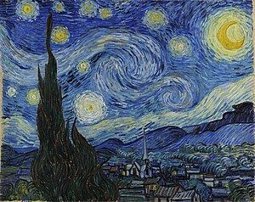

The Carol has a joyful feel to it as it retells of Jesus’ birth, the Shepherd’s visit and the Angels ringing out their praise and singing. Interestingly it clearly reminds us that Jesus was not just any boy but from heaven, from God but yet born as a baby boy.

Some Carols focus entirely on Jesus as Godly and take away realistic human features or so fully human that we lose some the mystery and wonder of God. Here we find the link as the bells of heaven ring out to tell people of the baby boy’s special birth. Enjoy!

Some Versions to enjoy.
https://youtu.be/MCHL2t7xxus Makaton version
https://youtu.be/gbEHFB6WLx4 childrens choir (use)
https://youtu.be/HeRrAzapOQ0 with lyrics
https://youtu.be/wrUkjS1voS4 Salvation army brass band (instrumental)

It was on a Starry Night

It was on a starry night
When the hills were bright
Earth lay sleeping, sleeping calm and still
Then in a cattle shed
In a manger bed
A boy was born, King of all the world

And all the angels sang for Him
The bells of heaven rang for Him
For a boy was born, King of all the world
And all the angels sang for Him
The bells of heaven rang for Him
For a boy was born, King of all the world

Soon the shepherds came that way
Where the baby lay
And were kneeling, kneeling by His side
And their hearts believed again
For the peace of men
For a boy was born, King of all the world

And all the angels sang for Him
The bells of heaven rang for Him
For a boy was born, King of all the world
And all the angels sang for Him
The bells of heaven rang for Him
For a boy was born, King of all the world

