Saturday 3rd April - 9am “live” Journeying with Jesus 3 – Dead and Buried

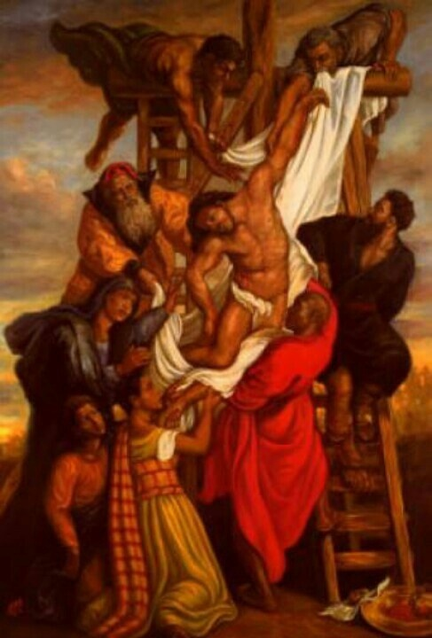
Descent From The Cross - 38x26 - print - Tim Ashkar | African american art, Black art, Christian art (pinterest.co.uk)

Mark 15

The Burial of Jesus
⁴² When evening had come, and since it was the day of Preparation, that is, the day before the sabbath, ⁴³ Joseph of Arimathea, a respected member of the council, who was also himself waiting expectantly for the kingdom of God, went boldly to Pilate and asked for the body of Jesus. ⁴⁴ Then Pilate wondered if he were already dead; and summoning the centurion, he asked him whether he had been dead for some time. ⁴⁵ When he learned from the centurion that he was dead, he granted the body to Joseph. ⁴⁶ Then Joseph^{[l]} bought a linen cloth, and taking down the body,^{[m]} wrapped it in the linen cloth, and laid it in a tomb that had been hewn out of the rock. He then rolled a stone against the door of the tomb. ⁴⁷ Mary Magdalene and Mary the mother of Jesus saw where the body^{[n]} was laid.

Dead and Buried
In Mark’s gospel the telling of Jesus being brought from the cross and laid in the tomb occupies just a few short verses. It tells of bravery in asking for Jesus’s body to be released, the checks by Pilate who is left wondering what is happening, the careful laying of his body in the funeral linen and stone rolled into place. Today we sit in the sadness of the moment. Imagining their despair and distress. Of a mother’s love and dedicated followers actions while they wait for the Sabbath to pass.

Today with the recent 1st anniversary of the initial covid lockdown we sit for a while and recognise the hardships, losses and uncertainty of our situation today. We acknowledge the blessings and hope we have ahead, knowing that many in our world have no perspective of that, just as those first disciples, follower and family had no concept of Easter joy.

Musical Reflection: Were you there? https://youtu.be/P4Aktws3V0s (end at 3.28)

Prayer

Lord, in our stillness, be with us and comfort us.
In our sadnesses, dwell with us and wait with us.
In our uncertainties, wait with us and hold us in your embrace.
In our waiting, help us to know your presence and rest in your love.
Amen

